8/17/07
Unchangeability and Changeability in the Original Image

Glenn C. Strait, Senior Editor
New World Encyclopedia
Washington, DC

Introduction: Unification Thought—fruit of the efforts of Dr. Sang Hun Lee (1914 - 1999) to conceptualize and systematize Rev. Dr. Sun Myung Moon’s profound insights into the nature of God, humankind, and the natural world—offers in its “Theory of the Original Image” a radical view of God elaborated in surprising detail. The article presented here aims to aid understanding and application of the Theory of the Original Image so it can fulfill its important role in guiding and supporting efforts to establish a peaceful, ideal world. A context for this article lies in the following words of Rev. Moon: “It should be added to the Divine Principle that God is the source of true love.”

Unification Thought (UT) accepts the widely held view that the created world, including human beings, is made in the image of the creator, God, who is also humankind’s heavenly parent. UT also accepts a second widely held view that humankind today falls tragically short of embodying that image, as shown by the fact that individuals, families, societies, and nations consistently and tragically fail to live up to their potential. As a global dysfunctional family, humans still wallow in self-centered, violent, licentious, and deadly behaviors.
Against such a backdrop, UT claims that an essential foundation for cleansing humankind from the stench of its modern depravities is knowledge of the nuanced nature of God. Building on the insights of Rev. Moon, UT dares to add content and structure to deity, and further to assert that only by knowing such content and structure and by conforming ourselves and society to it can we human beings solve our deepest problems.
“Unification Thought,” Dr. Lee writes, “is the thought which has appeared to lead humankind eternally by fundamentally solving all the difficult problems of humanity. Yet, the fundamental solution of all these difficult problems is possible only through a correct and full understanding of the attributes of God.”
Asserting that the essential fullness of God’s attributes, His Original Image, comprises Divine Image and Divine Character, Dr. Lee writes that “Only through a correct and full understanding of the Divine Image [Sungsang and Hyungsang, yang and yin, and individual images], as well as Divine Character [Heart, Logos, and Creativity] will we be able to fundamentally solve the problems of human life, society, history, and the world.” Getting the Original Image right then is of ultimate importance.

To Add More Love to Divine Principle
The suggestion of this article is that in his remarkable contribution of systematizing Rev. Moon’s thought, Dr. Lee came tantalizingly close to disclosing that the Original Image comprises not two, but three pairs of harmonized dual characteristics. The first two pairs, Sungsang /Hyungsang and yang /yin, are identified in Divine Principle and elaborated in Unification Thought.
The proposed third pair of dual characteristics, unchangeability / changeability, is not identified in either Divine Principle or Unification Thought as a pair of dual characteristics, but such a designation is foreshadowed in both the spoken word of Rev. Moon and the writings of Dr. Lee.
In November 1991 Rev. Moon spoke on at least three occasions of the need to “add” love to the description of God in the Divine Principle:

Quote 1. “How does the Divine Principle depict God? He is the Subject with dual characteristics in a union of harmony as well as the Subject of love. The word love must be added to the description without fail.” –November 10, 1991.

Quote 2. “God is the Subject of love. Doesn’t the Divine Principle refer to Him as a being with a harmonious union of dual characteristics? However, it has not been disclosed until now that He is also a unified being based on love maintaining a state of harmony. Therefore it should be added to His description that He is the being of unity based on love.”
–November 12, 1991. (emphasis added)

Quote 3. “Where is the origin of human love and life? Doesn’t it originate within God? He is the subject being with harmonized dual characteristics and at the same time is the source of love. It should be added in the Divine Principle that God is the source of true love.–November 24, 1991.

Despite Rev. Moon’s direction, it seems that the Divine Principle description of God has not been amended. One reason for the apparent inaction, perhaps, is that it has not been clear exactly how to make the change. We need a conceptual frame from which to process the apparently simple request—“It should be added in the Divine Principle that God is the source of true love.” (Quote 3.) This article suggests that by adapting the UT model of the Original Image it is possible to develop a conceptual frame that can meet Rev. Moon’s request.
The hypothesis presented here is that within the Original Image, in addition to the dual characteristics of Sungsang / Hyungsang and yang / yin, there exists a third set of dual characteristics: unchangeability / changeability associated respectively with the identity maintaining four position foundation and the developmental four position foundation.
Establishing the identity maintaining four position foundation with a central position in the Original Image opens the way for responding to Rev. Moon’s request that it should be added to DP that God is the source of true love and also that God is a unified being based on love maintaining a state of harmony. Establishing the dual characteristics of unchangeability / changeability within the Original Image opens the way to an integration of the world’s religions. These implications will be discussed later in the article, but first it is necessary to demonstrate support within UT for the hypothesized third set of dual characteristics in the Original Image.

Unchangeability and Changeability in the Original Image
In the Unification Thought series of books, Dr. Lee articulates, though somewhat obliquely, the concept that God’s attributes include both unchangeability and changeability. He may come closest to stating this clearly in the chapter on Methodology in which he states:

In God, there is the identity-maintaining, unchanging aspect in which His Sungsang and Hyungsang engage in give and receive action centering on Heart, and He exists eternally as a harmonized being, or a union; then, there is also the developmental aspect, in which His Sungsang and Hyungsang engage in give and receive action centering on purpose (purpose of creation) and produce a multiplied being, or a new being, namely, a created being. The first form of give and receive action is identity-maintaining give and receive action; the second is developmental give and receive action. All beings in the created world also perform identity-maintaining and developmental give and receive actions, maintaining both unchanging and changing aspects.(emphasis added)

Although this statement is about give and receive actions, not four position foundations, it does mention unchanging aspects and changing aspects by name and it explicitly correlates unchanging aspects with identity-maintaining give and receive actions and changing aspects with developmental give and receive actions. From there it is a short logical step to the correlation of the identity maintaining four position foundation with unchangeability and the developmental four position foundation with changeability. Dr. Lee makes the necessary association of give and receive action with the four position foundation:

Whether in the Original Image or in the created world, no matter what type of give and receive action it may be, without exception give and receive action takes place within the context of a four position foundation.

Thus Dr. Lee’s own writings set the foundation for asserting that within the Original Image the aspects of unchangeability and changeability coexist. This concept relates to the historically unsettled debate about whether God is unchanging or changing or both. Taking into account the considerable weight of accumulated debate on the issue, it is worth noting that the earlier quote from Methodology further includes within it several key insights that shed light on the issue of unchangeability and changeability in the Original Image. These insights include the following:

There are two persistent aspects coexisting in God: an “identity-maintaining, unchanging aspect” and a “developmental aspect.”
God’s Sungsang and His Hyungsang are somehow persistently engaging in two kinds of give and receive action: identity-maintaining and developmental.
God’s eternal existence as a harmonized being is sustained through the give and receive action between his Sungsang and Hyungsang centered on Heart.
God’s position as the creative source derives from the give and receive action between his Sungsang and Hyungsang centered on purpose.

Mapping Unchangeability and Changeability
UT provides another approach to the discussion of unchangeability and changeability in the Original Image. This is through a development of the UT diagrams. A simple re-drawing of one of UT’s key diagrams draws out the idea that unchangeability and changeability may actually constitute a third pair of dual characteristics in the Original Image.
The pivotal diagram is found in Dr. Lee’s final and consummate book, New Essentials of Unification Thought [NEUT], Unification Thought Institute, English translation, 2006. The diagram shows two different kinds of give-and-receive action that are said to be present in the Original Image—one is centered on heart and the other is centered on purpose. Here is the figure:

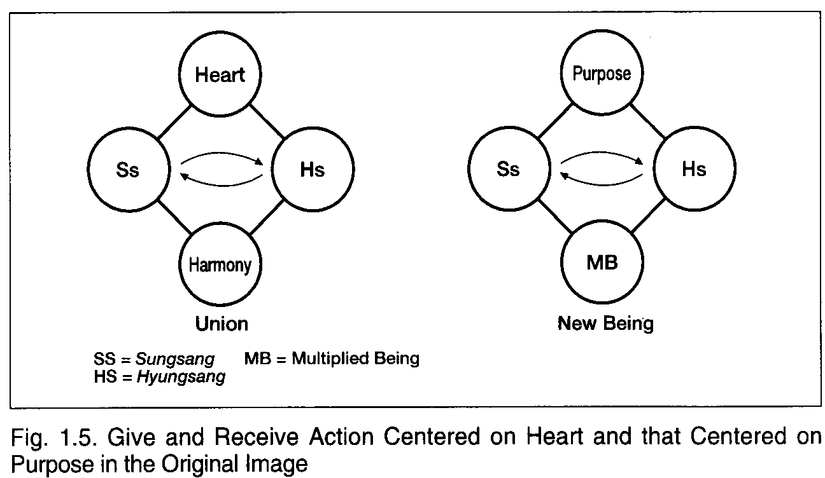
From New Essentials of Unification Thought: The Head-Wing Thought, p. 47.
Figure 1. The Original Diagram

Several important points are illustrated in “Figure 1. The Original Diagram.

- Although the figure caption mentions give-and-receive action, the figure clearly shows two four position foundations “in the Original Image”—one centered on heart and one centered on purpose.
- The four position foundation centered on heart yields “harmony” or “union.” This means that it is an identity-maintaining four position foundation.
- The four position foundation centered on purpose yields MB (“multiplied being”) or “new being.” This means that it is a developmental four-position foundation.
- The diagram thus is telling us that the Original Image comprises both an identity-maintaining four position foundation and a developmental four position foundation.

Labeling the two four position foundations helps to draw out the meaning of Fig. 1-5:

From New Essentials of Unification Thought: The Head-Wing Thought, p. 47.
Identity-Maintain-ing Four Position Foundation
Developmental Four Position Foundation
Figure 2. The Original Diagram with Its Four-Position Foundations Labeled

Structure in the absolute oneness
Bearing in mind Dr. Lee’s assertion that “The structure of the Original Image exists in oneness in the world transcending time and space,” we are drawn to look for a statement from him that would clarify the relation between these two four position foundations. Perhaps the most concise statement is the following (numbers added):
(1)Prior to God’s thinking of creation, the four position foundation centered on Heart, or the identity-maintaining four position foundation was formed in God. (2)Since Heart is an irrepressible emotional impulse, He could not help but establish the purpose of creation. (3)The developmental four position foundation was formed on the basis of this identity-maintaining four position foundation. (4)In other words, the identity-maintaining four position foundation (the unchangeability and absoluteness of God) remains as the basis of the developmental four position foundation even after His creation.

Paying close attention to these words of Dr. Lee, we can discern the following:
- The two four position foundations must coexist within the Original Image.(4)
- The two four position foundations share a common higher center: Heart.(2)
- The identity-maintaining four position foundation is the enduring basis of the developmental four position foundation.(4) As the basis, the identity-maintaining four position foundation, it seems, would likely be in the position of subject partner in the relationship with the developmental four position foundation.
- The two four position foundations together must form a new, heart-centered four position foundation whose fourth position embodies the oneness of unchangeability and changeability.

We are reassured to imagine such a higher level four position foundation when we read, “The Original Image is pure oneness. … the fundamental principles which rule time and space and all phenomena in the universe lie in this single point, namely, oneness. In other words, the principle of unification, the principle of give and receive action, and the principle of love lie in this single point.
Within the oneness, then, the identity-maintaining four position foundation and the developmental four position foundation must be related, and their relationship must surely be
harmonious. Harmonious relations, UT tells us, are those of give and receive action between subject and object partners interacting about a common center within a four position foundation.
Capturing these insights into a diagram involves applying two “transform tools”—circumscribing and bundling—as is shown in Figure 3. Deriving the Bundled Four Position Foundation (FPF) in the Original Image. Figure 3 begins by showing the pivotal figure, Fig. 1-5, reproduced as Figure 3A. The subsequent three figures, 3B, 3C, and 3D, show respectively the three simple steps, circumscribing, bundling, and again circumscribing, that are required to capture all of the bullet points above into a single diagram that shows the identity-maintaining four position foundation and the developmental four position foundation united in the Original Image.
The diagram brings an integral wholeness to the Original Image: by showing the common higher center of the two four position foundations as heart, by showing the resultant as Oneness, and by circumscribing the two four position foundations within the larger circle. Note that Figure 3D has also been labeled as “The Consolidated Original Image” and that the Sungsang (Ss) position in the developmental four position foundation is now labeled as Logos to be consistent with more advanced elaborations of UT.

Lessons from the Consolidated Original Image
Carrying on with Dr. Lee’s quest to present the Original Image as clearly as possible and gain subsequent insight from that presentation, let us now explore the rich world of the Consolidated Original Image, which lends itself well to serious analysis and interdisciplinary dialogue. We begin with analysis then proceed to dialogue and correlations. “Figure 4. The One God: Unchanging and Changing” encapsulates much of the following discussion.
First, what does the figure tell us about God? The figure shows us that God comprises the aspects of both unchangeability as sustained within the identity maintaining four position foundation and changeability as realized through the developmental four position foundation.
The assertion of changeability within God is a contentious matter and raising the issue in the context of this figure may help to sharpen the discussion. Here, the aspect of changeability in God is associated with the developmental four position foundation invested in fulfilling the purpose of creation, the embodiment on earth of God’s love, life, and lineage in divine sons and daughters. In the sphere of God’s developmental four position foundation, then, lies all of the creation process and as well the restoration process. If, as DP and UT teach, God desires to experience the fulfillment of a loving relation with His creation and especially with human beings, then it seems that in some way God must be compelled from His heart to seek after a certain kind of change, which for God may be at the emotional level embracing true love.
The Consolidated Original Image can aid understanding of Rev. Moon’s teaching that God, from His heart, willed His purpose to be fulfilled and invested Himself 100 percent toward fulfilling it, only to have His heart broken when His son and daughter failed to fulfill it. Here, the purpose is
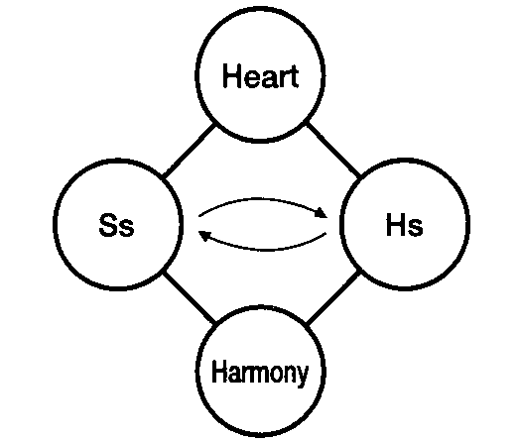
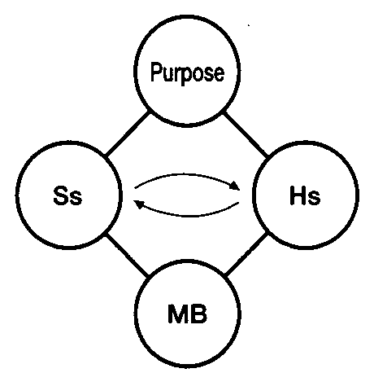
Figure 3. Deriving the Bundled Four Position Foundation (FPF)
In the Original Image
3A. Start with the Original Diagram
From New Essentials of Unification Thought: The Head-Wing Thought, p. 47.
Identity-Maintaining Four Position Foundation (IM-FPF)
Developmental Four Position Foundation (D-FPF)
3B. Circumscribe the two FPFs
IM--FPF
D--FPF
3C. Bundle the Two FPFs

Heart

Oneness

Heart

Oneness
3D. Circumscribe the Two Bundled FPFs
D-FPF
IM-FPF
Logos
The Consolidated Original Image
Figure 4. The One God: Unchanging and Changing
Source of Religions, Spiritualities, and Worldviews
In the Era Before the Coming of Heaven (Era of Indirect Dominion)

Heart
Heart

Oneness

Union
Unchanging
GOD
Pur-
pose
Sang
P
IHS
ISS

Logosss
U
Hyung Sang
IHS
ISS
H
New
Body
Changing
GOD
*”Since Buddhism teaches that all dharmas constantly change while the truth is found in the “such-ness” (jin-yeo) behind dharmas, we can say that “such-ness” constitutes the absolute being in Buddhism.”
--S.M. Moon, Cheon Seong Gyeong, p. 86.

Sung
Sang

Logos

Hyung Sang Sang

Union
THE UNCHANGING GOD
Through The Identity-
Maintaining FPF
======================================
IMAGE OF GOD
God of Eternal Return
--Divine Ground
--Cosmic Oneness

God of Peace, Calm, Bliss, and Love
======================================
THE HUMAN RESPONSE
Integration Stream Religions
Hinduism
Buddhism*
Sikhism

Mystical Spirituality
Sufism
Christian Mysticism,
New Thought Christianity
New Age
======================================
WORLDVIEW
Evil: Maya (the veil)
Existence: many earthly lives

Psychology: Love/Fear
Blessing Level:1st--
Mind-Body Unity

THE CHANGING GOD
Through The
Developmental FPF
======================================
IMAGE OF GOD
God of Providence
--Creation
--Restoration

God of Judgment, mercy, and Love

Unification God
(of restoration)
Heart of
Hope, Sorrow, Pain
======================================
THE HUMAN RESPONSE
Personalization Stream Religions
Judaism
Christianity
Islam
Restoration Unificationism
======================================
WORLDVIEW
Evil: Satan
Existence: one earthly life
Psychology: ???

Unificationist Blessing Level: 2nd & 3rd--Family,
Community, and Creation
unchanging but the price to God is that he be willing to enter the realm of changeability in which being privy to the joy of purpose fulfilled necessarily also entails being vulnerable to the pain of loss and failed purpose. Christians teach that God sacrificed his son to redeem the sins of humanity. Unificationism in this sense teaches that God sacrificed his unchangeability to claim the prize of love fulfilled.
If, as Rev. Moon teaches, God’s heart has been broken throughout human history before the coming of heaven, then it is likely that within the Original Image the identity-maintaining four position foundation and the developmental four position foundation, either within themselves or with each other, have not been fully harmonized. That harmonization would be expected after the coming of heaven.
The major world religions provide a fruitful demonstration of the analytical potential of the Consolidated Original Image as it opens new dimensions of interreligious dialogue by providing a way to visualize the one God who simultaneously is:

- Quiescent, absolute, and eternally unchangeable
- Active through history and providence
- Vulnerable to the pain of love lost and privy to the joy of love fulfilled

Within the large context that sees God as both unchanging and changing, the historical religions of Judaism, Christianity, Islam, and “Restoration Unificationism” align naturally with the changing aspect of God that has sought through creation and restoration to fulfill an original purpose. This God of Providence is one of judgment, mercy, and love; and human individual lives are singular, unique, and linear.
In complement, the religions of “eternal return” —Hinduism, Buddhism (see note on Figure 4), and Sikhism—align naturally with the unchanging aspect of God, as they have the sense that both individual lifetimes and historical periods are cyclical in nature. The God of eternal return is one of peace, calm, bliss, and love.
Outside the mainstreams of the historical religions and the three main religions of eternal return listed above, lies a large segment of humanity, which practices a wide spectrum of mystical spiritualities. These people would also align naturally with the unchanging aspect of God. The issues raised in the preceding discussion do not begin to exhaust the possibilities of analysis and dialogue opened by applying the transforms of circumscribing and bundling to the Original Image.

IM-FPF

D-FPF

Identity for God and Humankind
Reflections grounded in the insights offered by “Figure 4. The One God: Unchanging and Changing” bring to mind an important point brought to light in Dr. Lee’s correlation of human identity with the Original Image. He writes:

… in the created world, both the identity-maintaining four position base and the developmental four position base are centered on purpose (whereas in God the identity-maintaining four position base is centered on Heart). Since all created beings are created with a purpose, the very existence of a created being already contains purpose. … The same pattern is followed throughout the created world—which shows that the center of all four-position bases in the created world is purpose. This purpose, of course, should be based on heart (love). [emphasis added]

Because human beings are part of the created world, Dr. Lee’s statement seems to imply that in human beings all identity maintaining four position foundations are centered on purpose. This wording is important because Unificationists need to find the place conceptually of true love, living for the sake of others and mind-body unity—issues that have been strongly emphasized by Rev. Moon in recent years and that seem to be intrinsically centered more on heart than on purpose.
This issue brings us back to Rev. Moon’s direction of 1991, “It should be added in Divine Principle that God is the source of true love.” It seems that within the Original Image the Identity maintaining four position foundation must the source of God’s unchanging love essence originating in heart. If this is the case, then it would be important for UT to be very explicit in assuring humans that we embody an unchanging, identity maintaining four position foundation that is in the image of God’s own unchanging, identity maintaining four position foundation. This would seem to be important as an aid to knowing the true love of God.
Viewed within the framework of “Figure 4. The One God: Unchanging and Changing,” much of the personal growth work for developing a character manifesting the qualities of true love, living for the sake of others, and mind-body unity should be keyed to the heart-centered unchanging aspect of God. It would seem that human beings made in the image of God should aspire to emulate the identity-maintaining aspect of God that is centered on heart.
The assertion of “Figure 4. The One God: Unchanging and Changing” is that the heart-centered, identity-maintaining four position foundation of the Original Image is precisely the focus of the religions of eternal return and of the mystical practices. This assertion can help us understand an important development in the Unification movement.

A new Unificationist spirituality
In recent years, a new approach to Unificationist spirituality has been opened by Rev. Moon’s youngest son, Hyung Jin Moon, who has pursued rigorous self-disciplines with a Buddhist orientation, conducted mind-body unity retreats for Unificationists, and written a book on the subject: Cheon Hwa Dang: The House of Heaven’s Harmony, HSA Publications, 2006. There he reveals that his father is a master of the spirituality of silence. He writes:

God is always there to heal and support us. We just have to quiet ourselves. We have heard of the wisdom learned in the silence with God. Some of my most profound experiences are just sitting in total silence with True Father, before he goes out to Hoon Dok Hae.
In those silent moments I have experienced the deepest presence of God. I have at times been moved to tears in such silence, together with Father. At times I have felt such a profound communication, an utterly humbling silence that compels me to bow down and admit in my heart my inadequacies.

This reveals a side of Rev. Moon’s meditative practices about which he has rarely spoken, a side that in deep silence communicates with God at the level of pure being or ultimate reality, which is probably sustained as the identity maintaining four position foundation of the Original Image. Such meditative practice stands in contrast to the traditional Unificationist spirituality, at least as commonly experienced in the West. Through the Unification wilderness course that emphasized knowing God’s suffering heart and advancing the providential will, Unification members were at times strongly discouraged from exploring the meditative spiritualities as a protection from the distractions and temptations latent in many of the mystical spiritual practices. Now, in the era after the coming of heaven and after the special grace workshop, however, Unificationists surely should, with proper precaution, avail themselves of all possible modalities of spiritual growth and along the way educate the practitioners of those modalities in the larger providential and spiritual contexts of Unificationism.
Rev. Moon has said in his third Peace Speech:

The human mind is more elevated than the human body and the spirit is more elevated than the mind. God resides in a place more elevated than the spirit world, where our spirits are destined to pass on. Only when we have become completely one with God in true love are we complete.

Do we become “completely one with God in true love” by centering on purpose? Considering this question offers one approach to a deeper understanding of UT. Dr. Lee has written:

In human beings, heart is the core of the personality. Accordingly the perfection of one’s personality becomes possible only when one experiences the Heart of God. A person who has perfected his or her character by experiencing the Heart of God is, indeed, a being of heart.
When people continuously experience God’s Heart, they eventually come to inherit God’s Heart completely.

No doubt Dr. Lee is correct in what he says, and such a viewpoint has probably been characteristic of the Unification movement during the Unification wilderness course. Knowing the historical God’s grieving heart was to be the motivation for persevering through the layers of indemnity conditions required to relieve that grief and open the way to establish God’s kingdom of peace, unity, and joy.
Many Unificationists, however, failed to discover and sustain a relationship with the historical God’s grieving heart, and so many lost the motivation to persist in supporting the providence of restoration. Considering this fact in relation to the ideal articulated in UT and also in relation to “Figure 4. The One God: Unchanging and Changing” it seems clear that the person who can “continuously experience God’s heart” through life’s ups and downs would most likely be one who has already attained the kind of mind-body unity that seems to associate naturally with the identity-maintaining four position foundation of the Original Image. For the sake of healing the wounded hearts of many former and present Unificationists, it would seem important to consider the way that “Figure 4. The One God: Unchanging and Changing” can be applied toward developing new programs adapting best practices for achieving mind-body from among the many different approaches available today.

Centering on true love
It seems that while true love fulfills purpose it is not pursued for the sake of purpose. In the Unificationist Family Pledge, for example, each of its eight verses includes “cham sarang-eul joong-shim-ha-go” or in English “centering on true love.” Although each of the verses also includes a pledge toward some specific goal or purpose, the affirmation of “centering on true love” undergirds all of those pledges. Applying “Figure 4. The One God: Unchanging and Changing” we could easily surmise that “centering on true love” refers to my own heart-centered identity-maintaining four position foundation, which I am to perfect to be most like the Original Identity-Maintaining four position foundation.
When Hyung Jin Moon teaches mind-body unity, he is leading people to a knowingness of oneself that lies deeper than mental conceptions of purpose. He is leading his students toward a oneness with God from which can upwell an alignment with the heavenly purpose on the foundation of the long-sought mind-body unity.
Many issues can be raised and discussed under the stimulus of the diagram of “The One God: Unchanging and Changing.” These include not only unity of religions and unity of mind and body, but also issues of epistemology and psychology. An immediate connection with epistemology and logic arises because the UT Epistmology considers Unchangeability and Changeability as one of the Forms of Existence and UT Logic considers Unchangeability and Changeability as one of the Primary Categories. The diagram may provide an opening for drawing connections between Unificationist thought and the mainstreams of thought, thereby aiding the emergence of UT as a significant force in the marketplace of ideas and in world transformation. At the most basic level, the diagram provides a foundation for entering into the broader theological debate about the nature of God.
The diagram of “The One God: Unchanging and Changing” includes many details, some of which may admittedly be inaccurate. Regardless of such possible errors in the details, however, the question posed is “Do these diagrams, in fact, represent a new opening for rendering UT more understandable to both scholars and the general public?”
“The One God: Unchanging and Changing” claims to illuminate for us the identity of God. Following the logic of UT, if humans are indeed made in God’s image, we are therefore made in the image of “The One God: Unchanging and Changing,” and that diagram describes myself as well as God.
In recent years, Rev. Moon has spoken often of “owning” the Kingdom of Peace and Unity (Cheon Il Guk), which, he tells us, is now dawning on the earth. That kingdom is to be one that fulfills God’s ideal and purpose of creation, a dream that needs all possible support. If the drawing of “The One God: Unchanging and Changing” does indeed convey a reliable representation of God, then it can be an important aid toward the goal of claiming ownership of the Original Image as my own.
At the macroscopic level of world religions, the drawing of “The One God: Unchanging and Changing”—if it does indeed convey a reliable representation of God—must be seriously considered as the foundation for the “doctrine of ultimate reality” called for by Rev. Moon in 1982. At that time he stated, “The doctrine of ultimate reality for the new religion must reveal that the absolute beings of the different religions are not separate gods but one and the same God. The new religion will reveal the fact that all religions constitute a brotherhood established by God, with the theologies of each having embraced one particular aspect of God’s attributes. The new religion will complete the picture of God.” Identifying God with the additional third set of dual characteristics—unchangeability and changeability—does indeed seem to lay the foundation for meeting this objective.
The possibilities for further developments based on this article are substantial. These would include: 1) Elaborating the diagram of “The One God: Unchanging and Changing” to include “True Unificationism” in the union position representing direct dominion in the Era After the Coming of Heaven; 2) Exploring the way that the model presented here can interface with the corpus of dialogue by process theologians and others about the question of the nature of God in relation to unchangeability and changeability; 3) Offering a new level of integral wholeness to Unification Thought by applying to all of the UT diagrams the transforms of circumscribing and bundling as introduced here plus the additional third transform of nesting; 4) Advancing a new model of epistemology that would include perceptions from the physical senses, the spiritual senses, and the intuitive senses.
Many more topics could be developed as well. The hope is that this article can serve as a step toward bridging between the Divine Principle worldview as elaborated in Unification Thought and the leading edge of the mainstreams of modern academic studies, especially in the areas of theology, psychology, religion, spirituality, and medicine. All this could then help to open the way for the Theory of the Original Image to fulfill the great purpose envisioned by Dr. Lee.

Notes

“Restoration Unificationism” may be a new term. If it is then the credit for it goes to the Consolidated Original Image, which provides a means of differentiating visually between the Era Before the Coming of heaven and the Era After the Coming of Heaven. “Figure 4. The One God: Unchanging and Changing” covers only the Era Before the Coming of Heaven, so it must use the term “Restoration Unificationism.” The “True Unificationism” available in the era of Cheon Il Guk after the coming of heaven would embrace and fulfill the aspects and religions of both the Unchanging God and the Changing God. “True Unificationism” would appropriately be placed in the union position below and centered between the two columns of the Unchanging God and the Changing God. Developing that presentation is an important task remaining to be fulfilled.
Moon, Sun Myung, Cheon Seong Gyeong: Selections from the Speeches of True Parents (Seoul: Family Federation for World Peace and Unification, 2006) 1632.
New Essentials of Unification Thought: Head-Wing Thought [NEUT], English Translation (Tokyo, Unification Thought Institute, 2006) 1.
NEUT 1.
Moon, Cheon Seong Gyeong 1631-1632.
Moon, Cheon Seong Gyeong 1632.
Moon, Cheon Seong Gyeong 1632.
NEUT 492.
NEUT 43.
Essentials of Unification Thought: The Head-Wing Thought [ EUT] (Tokyo, Unification Thought Institute, 1992, Tokyo) 35.
NEUT 67.
NEUT 91.
EUT 33.
Moon, Hyung Jin, Cheon Hwa Dang: House of Heaven’s Harmony, (NewYork, HSA Publications, 2006) 80.
Moon, Sun Myung, “The True Owners in Establishing the Kingdom of Peace and Unity in Heaven and on Earth,” April 10, 2006, Seoul.
NEUT 164. 17 Moon, Cheong Seong Gyeong 86. References Moon, Hyung Jin, Cheon-Hwa-Dang: The House of Heaven’s Harmony, New York, New York: HSA Publications, 2006. Moon, Sun Myung, Cheon Seong Gyeong: Selections from the Speeches of True Parents, Seoul: Family Federation for World Peace and Unification, 2006. Moon, Sun Myung, “The True Owners in Establishing the Kingdom of Peace and Unity in Heaven and Earth,” speech delivered April 10, 2006 in Seoul, Korea. Unification Thought Institute. Essentials of Unification Thought: Head-Wing Thought, Tokyo: 1992. Unification Thought Institute. New Essentials of Unification Thought: Head-Wing Thought, Tokyo: 2006.

